BANK DASHBOARD

The business requirements and KPIs were predefined. The objective of this project was to understand these KPIs, analyze the data accordingly, and build meaningful dashboards to support decision-making.

DASHBOARD 1: SUMMARY
Key Performance Indicators (KPIs) Requirements:
1. Total Loan Applications: We need to calculate the total number of loan applications received during a specified period. Additionally, it is essential to monitor the Month-to-Date (MTD) Loan Applications and track changes Month-over-Month (MOM).
2. Total Funded Amount: Understanding the total amount of funds disbursed as loans is crucial. We also want to keep an eye on the MTD Total Funded Amount and analyse the Month-over-Month (MoM) changes in this metric.
3. Total Amount Received: Tracking the total amount received from borrowers is essential for assessing the bank's cash flow and loan repayment. We should analyse the Month-to-Date [MTD) Total Amount Received and observe the Month-over-Month (MoM) changes.
4. Average Interest Rate: Calculating the average interest rate across all loans, MTD, and monitoring the Month-over-Month (MoM) variations in interest rates will provide insights into our lending portfolio's overall cost.
5. Average Debt-to-Income Ratio (DTI): Evaluating the average DTI for our borrowers helps us gauge their financial heath. We need to compute the average DTI for all loans, MTD, and track Month-over-Month (MoM) fluctuations.

Good Loan v Bad Loan KPI's
Good Loan:
1. Good Loan Application Percentage
2. Good Loan Applications
3. Good Loan Funded Amount
4. Good Loan Total Received Amount
Bad Loan
1. Bad Loan Application Percentage
2. Bad Loan Applications
3. Bad Loan Funded Amount
4. Bad Loan Total Received Amount

Loan Status Grid View
In order to gain a comprehensive overview of our lending operations and monitor the performance of loans, we aim to create a grid view report categorized by 'Loan Status.' By providing insights into metrics such as 'Total Loan Applications,' 'Total Funded Amount,' 'Total Amount Received,' 'Month-to-Date (MTD) Funded Amount,' 'MTD Amount Received,' 'Average Interest Rate,' and 'Average Debt-to-Income Ratio (DTI),' this grid view will empower us to make data-driven decisions and assess the health of our loan portfolio.

DASHBOARD 2: OVERVIEW
CHARTS
1. Monthly Trends by Issue Date (Area Chart): To identify seasonality and long-term trends in lending activities
2. Regional Analysis by State (Shape Map): To identify regions with significant lending activity and assess regional disparities
3. Loan Term Analysis (Donut Chart): To allow the client to understand the distribution of loans across various term lengths.
4. Employee Length Analysis (Bar Chart): How lending metrics are distributed among borrowers with different employment lengths, helping us assess the impact of employment history on loan applications.
5. Loan Purpose Breakdown (Bar Chart): Will provide a visual breakdown of loan metrics based on the stated purposes of loans, aiding in the understanding of the primary reasons borrowers seek financing.
6. Home Ownership Analysis (Tree Map): For a hierarchical view of how home ownership impacts loan applications and disbursements.

Metrics to be shown: ‘Total loan applications’, ‘Total funded amount’, and ‘Total amount received’.

DASHBOARD 3: DETAILS
GRID
A need for a comprehensive 'Details Dashboard' that provides a consolidated view of all the essential information within our loan data. This Details Dashboard aims to offer a holistic snapshot of key loan-related metrics and data points, enabling users to access critical information efficiently.

Objective:
The primary objective of the Details Dashboard is to provide a comprehensive and user-friendly interface for accessing vital loan data. It will serve as a one-stop solution for users seeking detailed insights into our loan portfolio, borrower profiles, and loan performance.
Data Understanding (Column Description):
Data understanding is important because it helps us know what the data actually represents before using it for analysis. When we clearly understand each column, we can calculate KPIs correctly, avoid wrong assumptions, and make sure the insights truly reflect the business situation. It also helps in cleaning data properly and building dashboards that are clear, accurate, and useful for decision-making.
Column Name | Description
id | Unique identifier for each loan record
address_state | State of residence of the borrower
application_type | Indicates whether the loan application is individual or joint
emp_length | Shows how long the borrower has been working.
emp_title | Describes the borrower’s profession or role.
grade | Credit grade assigned to the loan based on risk
home_ownership | Borrower’s home ownership status (Rent, Own, Mortgage)
issue_date | Date when the loan was issued
last_credit_pull_date | Last date the borrower’s credit was checked
last_payment_date | Date of the most recent payment made
loan_status | Current status of the loan (Fully Paid, Current, Charged Off, etc.)
next_payment_date | Scheduled date of the next payment
member_id
  Unique identifier for the borrower
purpose | Purpose for which the loan was taken (e.g., debt consolidation, education)
sub_grade | Detailed credit risk category within the main grade
term | Duration of the loan (e.g., 36 months, 60 months)
verification_status | Status of income verification
annual_income
  Borrower’s annual income
dti | Debt-to-Income ratio of the borrower
installment | Monthly payment amount
Int_rate | Interest rate charged on the loan
loan_amount | Total loan amount approved
total_acc | Total number of credit accounts held by the borrower
Total_payment | Total amount paid by the borrower till date
What are KPIs?
KPI stands for Key Performance Indicator
KPIs are numbers or metrics that show how well a business or process is performing against its goals.
Scenario:
Imagine a scenario where a dashboard contains too many charts and metrics, but there is no clear focus on what is important.
In such cases:
- The dashboard looks crowded and confusing
- Business users struggle to understand what to focus on
- Decision-making becomes slow and ineffective
- Important insights get lost among unnecessary visuals
This situation usually occurs when:
- There is no proper requirement gathering
- The project goals are not clearly understood
- KPI requirements are not clearly defined
As a result, the dashboard fails to deliver value to business users.

With Well-Defined KPI Requirements
When KPI requirements are clearly defined:
- Only relevant and meaningful metrics are included
- The dashboard becomes clean and easy to interpret
- Stakeholders can quickly assess performance
- The dashboard supports data-driven decision-making
Thus, KPIs act as a foundation for building an effective and business-focused banking dashboard.

KPI’S:
1. Total Loan Applications
Total Loan Applications:
SELECT COUNT(id) AS total__loan_applications FROM bank_loan_data;
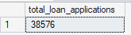

MTD Total loan applications:
SELECT COUNT(id) AS MTD_total_loan_applications FROM bank_loan_data
WHERE MONTH(issue_date) = 12 AND YEAR(issue_date) = 2021;
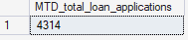

PMTD total loan applications:
SELECT COUNT(id) AS PMTD_total_loan_applications FROM bank_loan_data
WHERE MONTH(issue_date) = 11 AND YEAR(issue_date) = 2021;

2. Total Funded Amount
SELECT SUM(loan_amount) AS total_funded_amount FROM bank_loan_data;
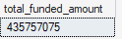

MTD Total Funded Amount:
SELECT SUM(loan_amount) AS MTD_total_funded_amount FROM bank_loan_data
WHERE MONTH(issue_date) = 12 AND YEAR(issue_date) = 2021;
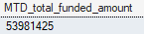

PMTD Total Funded Amount:
SELECT SUM(loan_amount) AS PMTD_total_funded_amount FROM bank_loan_data
WHERE MONTH(issue_date) = 11 AND YEAR(issue_date) = 2021;
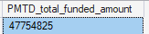

3. Total Amount Received
SELECT SUM(total_payment) AS Total_Amount_Received FROM bank_loan_data;
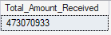

MTD_Total_Amount_Received
SELECT SUM(total_payment) AS MTD_Total_Amount_Received FROM bank_loan_data
WHERE MONTH(issue_date) = 12 AND YEAR(issue_date) = 2021;
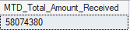

PMTD_Total_Amount_Received
SELECT SUM(total_payment) AS PMTD_Total_Amount_Received FROM bank_loan_data
WHERE MONTH(issue_date) = 11 AND YEAR(issue_date) = 2021;
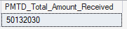

4. Average Interest Rate
SELECT AVG(int_rate) * 100 AS avg_interest_rate FROM bank_loan_data;
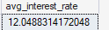
To round the above value upto 2 decimal points:
SELECT ROUND(AVG(int_rate),4)*100 AS avg_interest_rate FROM bank_loan_data;
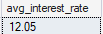

MTD Average Interest Rate
SELECT ROUND(AVG(int_rate),4)*100 AS MTD_avg_interest_rate FROM bank_loan_data
WHERE MONTH(issue_date) = 12 AND YEAR(issue_date) = 2021;
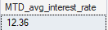

MTD Average Interest Rate
SELECT ROUND(AVG(int_rate),4)*100 AS PMTD_avg_interest_rate FROM bank_loan_data
WHERE MONTH(issue_date) = 11 AND YEAR(issue_date) = 2021;
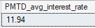

5. Average Debt-to-Income Ratio (DTI)
SELECT ROUND(AVG(dti),4) * 100 AS average_dti_ratio FROM bank_loan_data;
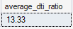

MTD Average DTI Ratio
SELECT ROUND(AVG(dti),4) * 100 AS MTD_average_dti_ratio FROM bank_loan_data
WHERE MONTH(issue_date) = 12 AND YEAR(issue_date) = 2021;
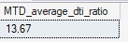

PMTD Average DTI Ratio
SELECT ROUND(AVG(dti),4) * 100 AS PMTD_average_dti_ratio FROM bank_loan_data
WHERE MONTH(issue_date) = 12 AND YEAR(issue_date) = 2021;
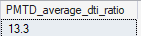

Good Loan:
Good Loan Application Percentage
SELECT (COUNT(CASE WHEN loan_status IN ('Fully Paid', 'Current' )THEN id END) * 100) /
COUNT(id) AS Good_Loan_Percentage
FROM bank_loan_data;
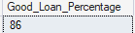

Good Loan Applications
SELECT COUNT(id) AS Good_Loan_Applications FROM bank_loan_data
WHERE loan_status IN ('Fully Paid','Current');
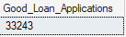

Good Loan Funded Amount
SELECT SUM(loan_amount) AS Good_Loan_Funded_Amount FROM bank_loan_data
WHERE loan_status IN ('Fully Paid','Current');
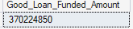

Good Loan Total Received Amount
SELECT SUM(total_payment) AS Good_Loan_Received_Amount FROM bank_loan_data
WHERE loan_status IN ('Fully Paid','Current');
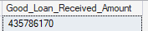

Bad Loan
Bad Loan Application Percentage
SELECT (COUNT(CASE WHEN loan_status = 'Charged Off' THEN id END) * 100) /
COUNT(id) AS Bad_Loan_Percentage
FROM bank_loan_data;
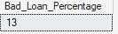

Bad Loan Applications
SELECT COUNT(id) AS Bad_Loan_Applications FROM bank_loan_data
WHERE loan_status IN ('Charged Off');
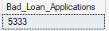

Bad Loan Funded Amount
SELECT SUM(loan_amount) AS Bad_Loan_Funded_Amount FROM bank_loan_data
WHERE loan_status IN ('Charged Off');
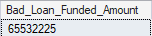

Bad Loan Total Received Amount
SELECT SUM(total_payment) AS Bad_Loan_Received_Amount FROM bank_loan_data
WHERE loan_status IN ('Charged Off');
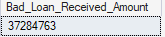

Loan Status Grid View
SELECT loan_status,
COUNT(id) AS Total_Loan_Applications,
SUM(loan_amount) AS Total_Funded_Amount,
SUM(total_payment) AS Total_Amount_Received,
AVG(int_rate * 100) AS Avg_Interest_Rate,
AVG(dti * 100) AS Avg_Debt_To_Income_Ratio
FROM bank_loan_data
Group BY loan_status;

SELECT loan_status,
SUM(loan_amount) AS MTD_Total_Funded_Amount,
SUM(total_payment) AS MTD_Total_Amount_Received
FROM bank_loan_data
WHERE MONTH(issue_date) = 12
Group BY loan_status;
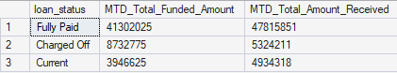

CHARTS
1.Monthly Trends by Issue Date (Line Chart): To identify seasonality and long-term trends in lending activities
SELECT MONTH(issue_date) as Month_Number,
DATENAME(MONTH, issue_date) AS month_name,
COUNT(id) AS total_loan_applications,
SUM(loan_amount) AS total_funded_amount,
SUM(total_payment) AS total_received_amount
FROM bank_loan_data
GROUP BY MONTH(issue_date), DATENAME(MONTH, issue_date)
order by MONTH(issue_date);

Explanation:
This query is used to analyze monthly lending trends based on the loan issue date. It groups loan records by month and calculates key metrics to understand how lending activity changes over time.
- Month_Number and Month_Name are used to identify each month and maintain proper order in the analysis.
- Total Loan Applications shows how many loans were issued in each month.
- Total Funded Amount represents the total loan amount disbursed during each month.
- Total Received Amount shows the total amount collected from borrowers for loans issued in that month.
By grouping the data month-wise, this query helps identify seasonal patterns, peak months, and long-term trends in loan applications, funding, and repayments.
Output:
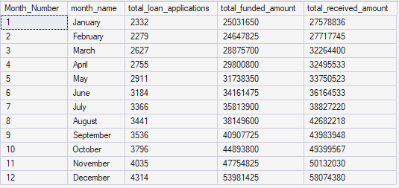

2.Regional Analysis by State (Filled Map): To identify regions with significant lending activity and assess regional disparities
SELECT address_state,
COUNT(id) AS total_loan_applications,
SUM(loan_amount) AS total_funded_amount,
SUM(total_payment) AS total_received_amount
FROM bank_loan_data
GROUP BY address_state ORDER BY SUM(loan_amount) DESC;
Explanation:
This query is used to analyze lending performance across different states. It groups loan records by the borrower’s state and calculates key lending metrics for each region.
- Total Loan Applications shows how many loan applications were received from each state.
- Total Funded Amount represents the total loan amount disbursed in each state.
- Total Received Amount shows how much money has been collected from borrowers in each state.
- The results are ordered by total funded amount in descending order to easily identify states with the highest lending activity.
This analysis helps understand regional demand, performance differences, and high-performing states, which supports region-based decision-making.
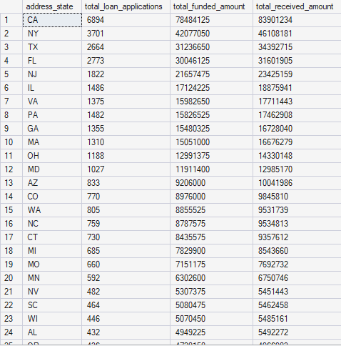
3.Loan Term Analysis (Donut Chart): To allow the client to understand the distribution of loans across various term lengths.
SELECT term,
COUNT(id) AS total_loan_applications,
SUM(loan_amount) AS total_funded_amount,
SUM(total_payment) AS total_received_amount
FROM bank_loan_data
GROUP BY term
order by term;
Explanation:
This query analyzes loan performance based on the loan term (such as 36 months or 60 months). It groups loan records by term and calculates key lending metrics for each loan duration.
- Total Loan Applications shows how many loans were issued for each term.
- Total Funded Amount represents the total loan amount disbursed for each term.
- Total Received Amount shows the total amount collected from borrowers for each term.
- The results are ordered by loan term for easy comparison.
This analysis helps understand borrower preferences, compare short-term and long-term loans, and evaluate repayment behavior across different loan durations.

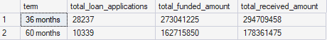

4. Employee Length Analysis (Bar Chart): How lending metrics are distributed among borrowers with different employment lengths, helping us assess the impact of employment history on loan applications.
SELECT emp_length,
COUNT(id) AS total_loan_applications,
SUM(loan_amount) AS total_funded_amount,
SUM(total_payment) AS total_received_amount
FROM bank_loan_data
GROUP BY emp_length
ORDER BY emp_length;
Explanation:
This query groups loan records by employment length and shows how many loan applications were made for each group, along with the total loan amount funded and the total amount received. The results are sorted by the number of loan applications, helping identify which employment lengths have the highest lending activity.
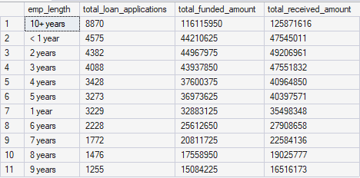

5. Loan Purpose Breakdown (Bar Chart): Will provide a visual breakdown of loan metrics based on the stated purposes of loans, aiding in the understanding of the primary reasons borrowers seek financing.
SELECT purpose,
COUNT(id) AS total_loan_applications,
SUM(loan_amount) AS total_funded_amount,
SUM(total_payment) AS total_received_amount
FROM bank_loan_data
GROUP BY purpose
ORDER BY COUNT(id) DESC;
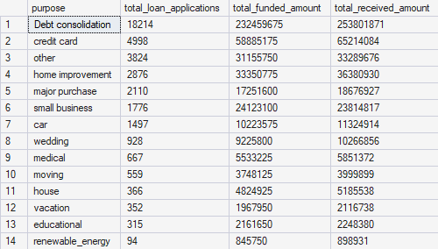
Explanation:
This query analyzes loans based on the purpose for which borrowers applied. It groups loan records by loan purpose and calculates key lending metrics for each category.
- Total Loan Applications shows how many loans were taken for each purpose.
- Total Funded Amount represents the total loan amount disbursed for each purpose.
- Total Received Amount shows how much money has been collected from borrowers for each purpose.
- The results are ordered by the number of loan applications, making it easy to identify the most common reasons borrowers seek loans.
This analysis helps understand customer needs, popular loan purposes, and lending patterns, which supports better product and marketing decisions.

6. Home Ownership Analysis (Tree Map): For a hierarchical view of how home ownership impacts loan applications and disbursements.
SELECT home_ownership,
COUNT(id) AS total_loan_applications,
SUM(loan_amount) AS total_funded_amount,
SUM(total_payment) AS total_received_amount
FROM bank_loan_data
GROUP BY home_ownership
ORDER BY COUNT(id) DESC;

Explanation:
This query shows how loan activity varies based on the borrower’s home ownership status. It groups loans by home ownership and summarizes key lending numbers.
- Total Loan Applications shows how many loans come from each home ownership category.
- Total Funded Amount shows how much loan money is given to each group.
- Total Received Amount shows how much money is collected from borrowers in each group.
- The data is sorted by loan count to easily see which home ownership type has the most loans.
This helps understand how home ownership relates to borrowing and repayment behavior.

Power BI Dashboard Creation
Power BI is a business intelligence tool used to analyze data, create interactive dashboards, and generate insights that support decision-making. After completing data analysis and KPI calculations using SQL, I moved to Power BI to design and develop the dashboards.
Data Preparation
Once the data was loaded into Power BI, I first checked the data quality by validating data types, identifying missing or inconsistent values, and performing necessary data cleaning. This step ensured the data was reliable before building visuals and measures.
Date Table Creation
To support time-based analysis such as Month-to-Date (MTD) and Year-to-Date (YTD) calculations, I created a separate Date Table. The date table contains date-related columns such as Date and Month, which are required for Power BI time intelligence functions.

Data Modeling
For effective data modeling, I created a relationship between the Date column in the Date Table and the Issue Date column in the Bank Loan Data table.
- The relationship is one-to-many, where:
  - Date Table acts as the one side
  - Bank Loan Data acts as the many side
- This allows a single date from the date table to relate to multiple loan records issued on that date.
This relationship enables accurate time-based filtering, aggregation, and calculation across the dashboard.
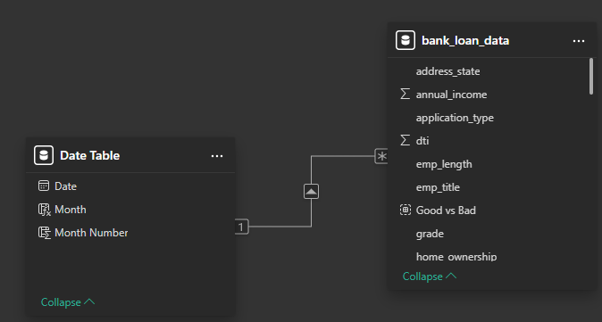

The Date Table is used as the primary time reference for all visuals and measures.
Proper data modeling improves performance, consistency, and accuracy of time intelligence calculations.
This setup ensures all MTD, YTD, and trend-based insights work correctly across the dashboard.

Dashboard Design and Color Selection
After completing data modeling and measure creation, I moved to the canvas area to design the dashboard layout and choose appropriate colors. Dashboard design is not only about KPIs and charts, but also about how information is visually presented.
Color selection plays an important role in creating a strong first impression. Even if the KPIs, charts, and filters are correctly built, poor color choices can make the dashboard look confusing or less professional.
While selecting colors, the focus was on:
- Keeping a clean and consistent color theme
- Using colors that are easy on the eyes
- Highlighting important KPIs without overusing bright colors
- Maintaining clarity and readability across all visuals
A well-chosen color palette helps users quickly understand insights, improves usability, and makes the dashboard more engaging and effective.

DAX:
DAX (Data Analysis Expressions) is a formula language used in Power BI to perform calculations and data analysis.
It helps create measures and calculated columns for KPIs, percentages, and time-based metrics.
DAX enables dynamic and interactive dashboards by responding to filters, slicers, and user selections.

The same DAX logic used for Total Loan Applications is reused for Total Funded Amount and Total Amount Received.
Only the base column or measure is changed, while the rest of the calculation remains exactly the same.
This ensures consistency across all KPIs and simplifies measure creation.

Total Loan Applications = COUNT(bank_loan_data[id]),
MTD Total Loan Applications = CALCULATE(TOTALMTD([Total Loan Applications],'Date Table'[Date]))
Month on month change = (MTD –PMTD)/ PMTD
PMTD = CALCULATE([Total Loan Applications], DATESMTD(DATEADD('Date Table'[Date],-1, MONTH)))

DASHBOARD 2: Charts
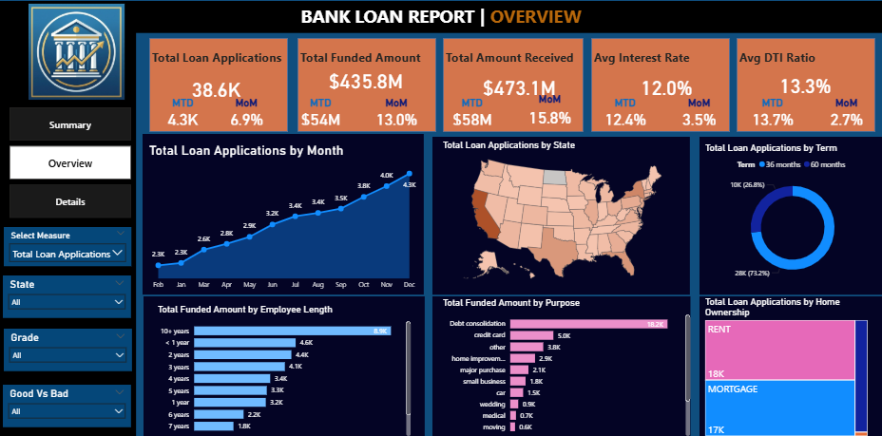
1.Monthly Trends by Issue Date (Line Chart – Dynamic)
- A Line Chart was created to analyze monthly loan trends based on the Issue Date.
- A Field Parameter was used to make the chart dynamic instead of creating multiple separate visuals.
- Rather than adding a single field (such as Total Loan Applications or Total Funded Amount) to the chart, a Select Measure option was provided using the field parameter.
- This allows users to choose between Total Loan Applications, Total Funded Amount, and Total Amount Received within the same chart.
- The X-axis represents months from the Date table, ensuring proper time intelligence.
- The Y-axis changes dynamically based on the selected measure.
- This design reduces visual clutter and keeps the dashboard clean.
- It helps users easily identify seasonality, trends, and month-to-month changes in lending activity.

2. Regional Analysis by State (Shape Map)
- A Shape Map was used to analyze loan distribution across different states.
- This visual helps identify regions with high, medium, and low lending activity based on the selected measure.
- Color density was applied to represent variation in loan metrics, where darker shades indicate higher values and lighter shades indicate lower values.
- The analysis supports multiple measures such as Total Loan Applications, Total Funded Amount, and Total Amount Received, allowing flexible regional comparison.
- This visualization makes it easy to assess regional disparities and identify states contributing most to overall lending performance.
- It enables stakeholders to quickly spot concentration areas and potential regions for business growth or risk assessment.
3. Loan Term Analysis (Donut Chart)
- A Donut Chart was used to visualize the distribution of loans across different loan terms.
- This chart helps understand how loan applications are split between short-term and long-term loan options.
- Each segment of the donut represents a loan term category, sized based on the selected lending measure.
- Key metrics such as Total Loan Applications, Total Funded Amount, or Total Amount Received can be used to analyze term-wise distribution.
- The donut chart provides a quick comparison of loan term preferences among borrowers.
- This insight helps the business evaluate demand for different loan durations and plan lending strategies accordingly.

4. Employee Length Analysis (Bar Chart)
- A Bar Chart was created to analyze loan metrics based on the borrower’s employment length.
- The chart shows how loan applications are distributed across different employee experience levels.
- Employment length is displayed on the X-axis, while lending metrics such as Total Loan Applications, Total Funded Amount, or Total Amount Received are shown on the Y-axis.
- This analysis helps assess how employment stability impacts loan applications and approvals.
- It also highlights which employee length categories contribute most to overall lending activity.
- The bar chart makes it easy to compare trends across different employment durations and identify potential risk or opportunity segments.

5. Loan Purpose Breakdown (Bar Chart)
- A Bar Chart was used to analyze loan metrics based on the purpose of the loan.
- The chart displays different loan purposes such as education, debt consolidation, home improvement, and others.
- Loan purposes are shown on the X-axis, while key metrics like Total Loan Applications, Total Funded Amount, or Total Amount Received are shown on the Y-axis.
- This visualization helps identify the primary reasons borrowers seek loans.
- It allows the business to understand demand patterns and focus on high-volume or high-value loan purposes.
- The bar chart enables easy comparison across different loan purposes.

6. Home Ownership Analysis (Tree Map)
- A Tree Map was used to analyze loan distribution based on home ownership status.
- The visual provides a hierarchical view, showing how loan activity is split among categories such as owning, renting, or mortgaged homes.
- Each block represents a home ownership category, with size indicating the selected loan metric.
- Color intensity helps highlight categories with higher or lower lending activity.
- This analysis helps understand how home ownership impacts loan applications and loan disbursement behavior.
- It supports quick identification of borrower segments that contribute most to the loan portfolio.

DASHBOARD 3: DETAILS (Grid View)
- A Details Dashboard was created to provide a consolidated view of all key loan-related information in one place.
- This dashboard presents detailed loan data in a grid format, allowing users to view multiple metrics and attributes together.
- It serves as a single source for exploring loan-level details such as loan status, funded amount, repayment details, interest rate, and borrower information.
- The grid view enables users to filter, sort, and scan data easily based on their requirements.
- This dashboard supports quick validation, deeper analysis, and ad-hoc investigation without switching between multiple visuals.
- Overall, it offers a holistic snapshot of the loan portfolio and helps users access critical information efficiently.
Page Navigator
- A Page Navigator was added to the report to enable smooth navigation between dashboards.
- The navigator allows users to easily switch between the Summary, Overview, and Details pages.

Key Insights from the Dashboard
Overall Loan Performance
- The bank received a total of 38.6K loan applications, with 4.3K applications Month-to-Date and a 6.9% MoM growth, indicating steady demand.
- The total funded amount stands at $435.8M, while the total amount received is higher at $473.1M, reflecting healthy repayment behavior.
- The average interest rate is 12%, and the average DTI ratio is 13.3%, suggesting a balanced risk profile across borrowers.

Loan Quality Insights (Good vs Bad Loans)
- Good Loans account for 86.2% of total loan applications, showing a strong and stable loan portfolio.
- A total of 33.33K applications fall under the Good Loan category, with $370.2M funded and $435.8M received.
- Bad Loans make up only 13.8%, with 5K applications, $65.5M funded, and $37.3M received, indicating controlled credit risk.
- Fully Paid and Current loans were classified as Good Loans, while Charged Off loans were treated as Bad Loans.

Monthly Trend Insights
- December recorded the highest activity across all metrics:
  - 4.3K loan applications
  - $54M funded
  - $58M received
- January and February consistently showed the lowest values, indicating possible seasonal slowdown in lending activity.

Regional (State-wise) Insights
- California (CA) dominates lending activity:
  - 6,894 loan applications
  - $78M total funded amount
  - Highest total amount received
- This highlights a strong regional concentration of loan demand and performance in CA.

Loan Term Insights
- 36-month loans are clearly preferred:
  - 28K applications (73.2%)
  - $273.04M funded
  - $294.71M received (62.3%)
- 60-month loans account for fewer applications (10K) but still contribute significantly to funded and received amounts.

Employment Length Insights
- Borrowers with 10+ years of employment contribute the most:
  - 8.5K applications
  - $116M funded
  - $126M received
- Applicants with less than 1 year and 2–3 years of experience also show notable participation, indicating demand across both stable and early-career segments.

Loan Purpose Insights
- Debt Consolidation is the primary reason for borrowing:
  - 18.2K applications
  - $232.4M funded
  - $254M received
- This is followed by Credit Card and Home Improvement loans, which form secondary borrowing purposes.

Home Ownership Insights
- Borrowers with Mortgage status contribute the highest value:
  - $219.33M funded
  - $238.47M received
- Renters represent the highest number of applications (18K) and also contribute significantly to funded and received amounts.
- This shows strong loan demand from both mortgaged homeowners and renters.

Overall, the dashboard reveals a healthy loan portfolio with strong repayment behavior, clear borrower preferences, and concentrated regional and purpose-based lending patterns.

